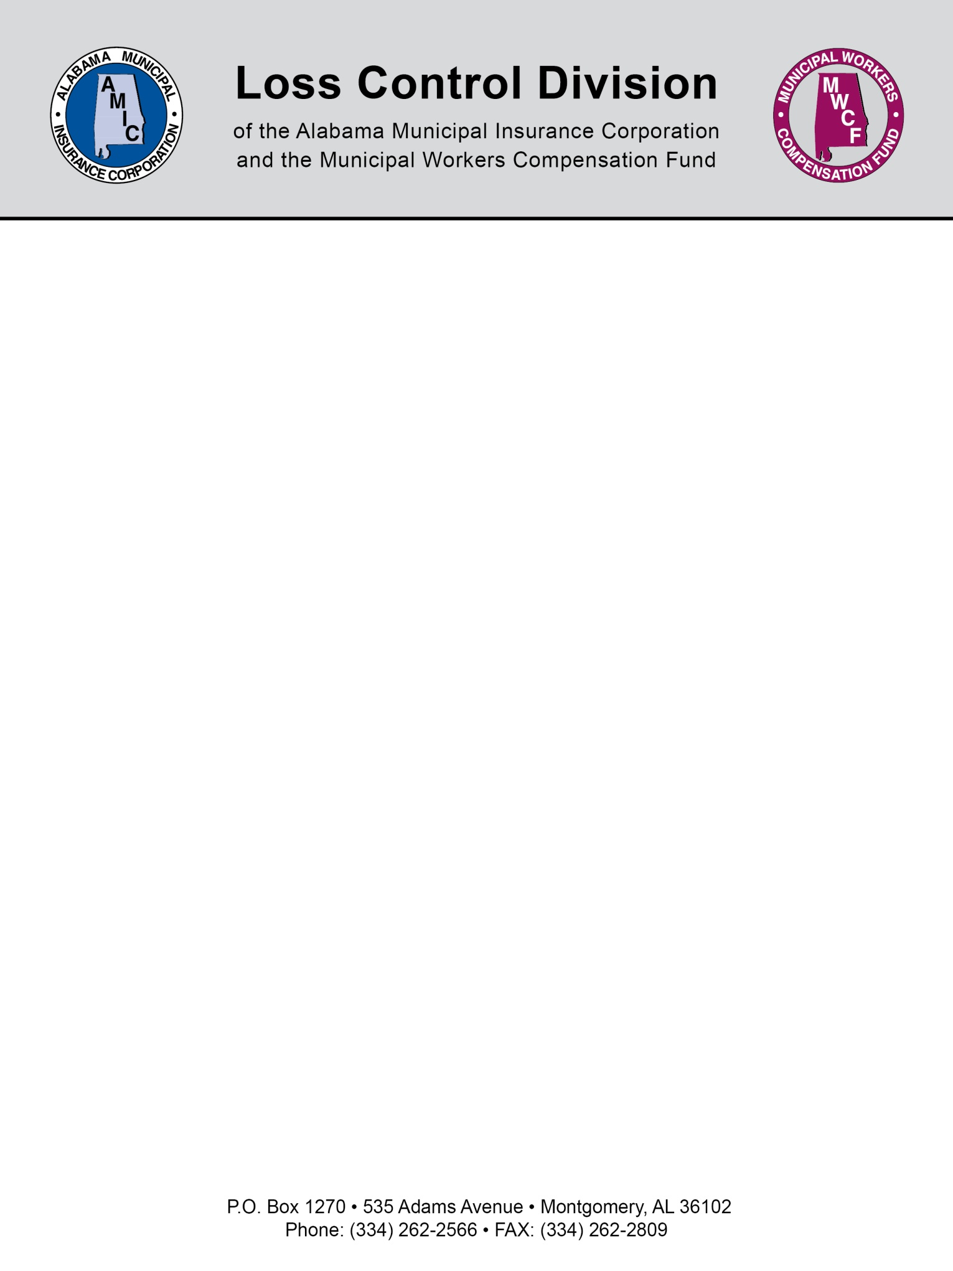

PERFORM MOTOR VEHICLE RECORD CHECKS

Examine applicants’ driving records carefully and consistently as a routine part of the screening, background investigation, and hiring process.

The driving record is a good indicator of future performance. Thoroughly evaluate drivers with histories of traffic violations or accidents.

The following is a partial list of conditions or convictions that should cause immediate concern:

- Two at fault accidents in the past three (3) years, or
- Two incidents in the past three (3) years as a result of which the individual was found responsible for committing civil infractions while operating a motor vehicle, or
- In the past three (3) years a combination of one (1) at fault accident and one (1) incident as a result of which the individual was found responsible for committing a civil infraction, or
- Operating under the influence of liquor or drugs, or
- Failure to stop or report an accident, or
- Negligent homicide, manslaughter, assaults involving the operation of a motor vehicle, or
- Driving on a suspended or revoked license.

Check that candidates possess, or can obtain any special license endorsements required by law – for example, a Commercial Driver’s License (CDL) – for the type(s) of vehicle they will operate in the performance of their duties.

Motor Vehicle Records may be obtained by three possible methods: by phone, mail, or in person. To obtain by phone, please call 334-242-4241. To obtain MVR’s in person, visit any of the ten Driver License Examining District Offices. Locations of the nearest District Offices can found at www.alea.gov. To obtain MVR’s by mail, fill in the appropriate request form and mail to the address below. Employers should use the “Third Party Request Form” located at www.alea.gov, select “Driver License” under the “Quick Links” section, then select the “Forms” link.

A fee of $5.75 for each MVR is required. Contact ALEA for approved payment methods and submit your request to:

Alabama Law Enforcement Agency
Licensing Bureau
P. O. Box 1471
Montgomery, AL 36102-1471

For questions regarding Motor Vehicle Records or payment methods, you may call (334) 242-4241 or visit your nearest Driver License Examining District Office.

NOTE: This document is not intended to be legal advice. It does not identify all the issues surrounding the particular topic. Public agencies are encouraged to review their procedures with an expert or an attorney who is knowledgeable about the topic. Reliance on this information is at the sole risk of the user.

Revised 1/2017

